NAME:ROSHINI B T
REG NO:192524064
CO5-AT1
EXPERIMENT NO. 33
BOOLEAN CIRCUIT SATISFIABILITY
(NP-Complete Problem)

QUESTION
Determine whether a Boolean circuit produces a true output for some input assignment. Clearly define constraints related to logical gate operations, analyze how constraints propagate through the circuit, and develop a backtracking-based solution to test input combinations. Apply pruning techniques to eliminate invalid assignments, justify correctness, and explain the NP-Complete nature of the problem.

AIM
To implement the Boolean Circuit Satisfiability problem using a backtracking technique and determine an input assignment that makes the output of a given Boolean circuit TRUE.

PROBLEM DEFINITION
Boolean Circuit Satisfiability asks whether there exists at least one assignment of Boolean values (0 or 1) to the input variables of a logical circuit such that the final circuit output is TRUE (1). The circuit is represented using logical gates such as AND and OR.
For this experiment, the circuit used is: Output = (X1 AND X2) OR (X2 OR X3). The three inputs X1, X2 and X3 can each take either 0 (FALSE) or 1 (TRUE). The program systematically explores possible assignments using recursion and backtracking.

4. CONSTRAINTS
Constraint | Description
Input constraint | Each input variable must have a Boolean value: 0 or 1.
AND gate constraint | The AND gate produces TRUE only when both its inputs are TRUE.
OR gate constraint | The OR gate produces TRUE when at least one of its inputs is TRUE.
Circuit output constraint | The final output must be TRUE for an assignment to be considered satisfying.
Assignment constraint | Every input must be assigned before the circuit is finally evaluated.

CIRCUIT ANALYSIS
The circuit is evaluated in two intermediate stages:
G1 = X1 AND X2
G2 = X2 OR X3
Final Output = G1 OR G2
The backtracking algorithm starts with the first variable and tries FALSE (0) and TRUE (1). It recursively assigns values to the remaining variables. When all variables have been assigned, the circuit is evaluated. If the output is TRUE, the assignment is reported as a satisfying assignment.

PSEUDOCODE
BACKTRACK(x, index)
IF index == N
IF EVALUATE_CIRCUIT(x) == TRUE
PRINT satisfying assignment
RETURN TRUE
ELSE
RETURN FALSE

x[index] = 0
IF BACKTRACK(x, index + 1) == TRUE
RETURN TRUE

x[index] = 1
IF BACKTRACK(x, index + 1) == TRUE
RETURN TRUE

RETURN FALSE

EVALUATE_CIRCUIT(x)
G1 = X1 AND X2
G2 = X2 OR X3
OUTPUT = G1 OR G2
RETURN OUTPUT

SOURCE CODE (C)
#include <stdio.h>
#include <stdbool.h>

#define N 3

// Function to evaluate the Boolean circuit
bool evaluateCircuit(bool x[])
{
// Circuit:
// G1 = X1 AND X2
// G2 = X2 OR X3
// Output = G1 OR G2

bool G1 = x[0] && x[1];
bool G2 = x[1] || x[2];

return G1 || G2;
}

// Backtracking function
bool backtrack(bool x[], int index)
{
// All inputs assigned
if (index == N)
{
if (evaluateCircuit(x))
{
printf("\nSatisfying assignment found:\n");

for (int i = 0; i < N; i++)
printf("X%d = %d\n", i + 1, x[i]);

return true;
}

return false;
}

// Try assigning 0
x[index] = false;

if (backtrack(x, index + 1))
return true;

// Try assigning 1
x[index] = true;

if (backtrack(x, index + 1))
return true;

// Backtrack
return false;
}

int main()
{
bool x[N];

printf("Boolean Circuit Satisfiability Problem\n");
printf("Circuit: (X1 AND X2) OR (X2 OR X3)\n");

if (!backtrack(x, 0))
printf("\nNo satisfying assignment exists.\n");

return 0;
}

INPUT
The program does not require keyboard input. It internally considers three Boolean variables X1, X2 and X3, each of which can take the values 0 or 1.

OUTPUT
The following output was obtained by executing the C program in an online C compiler. The program successfully identified a satisfying assignment.
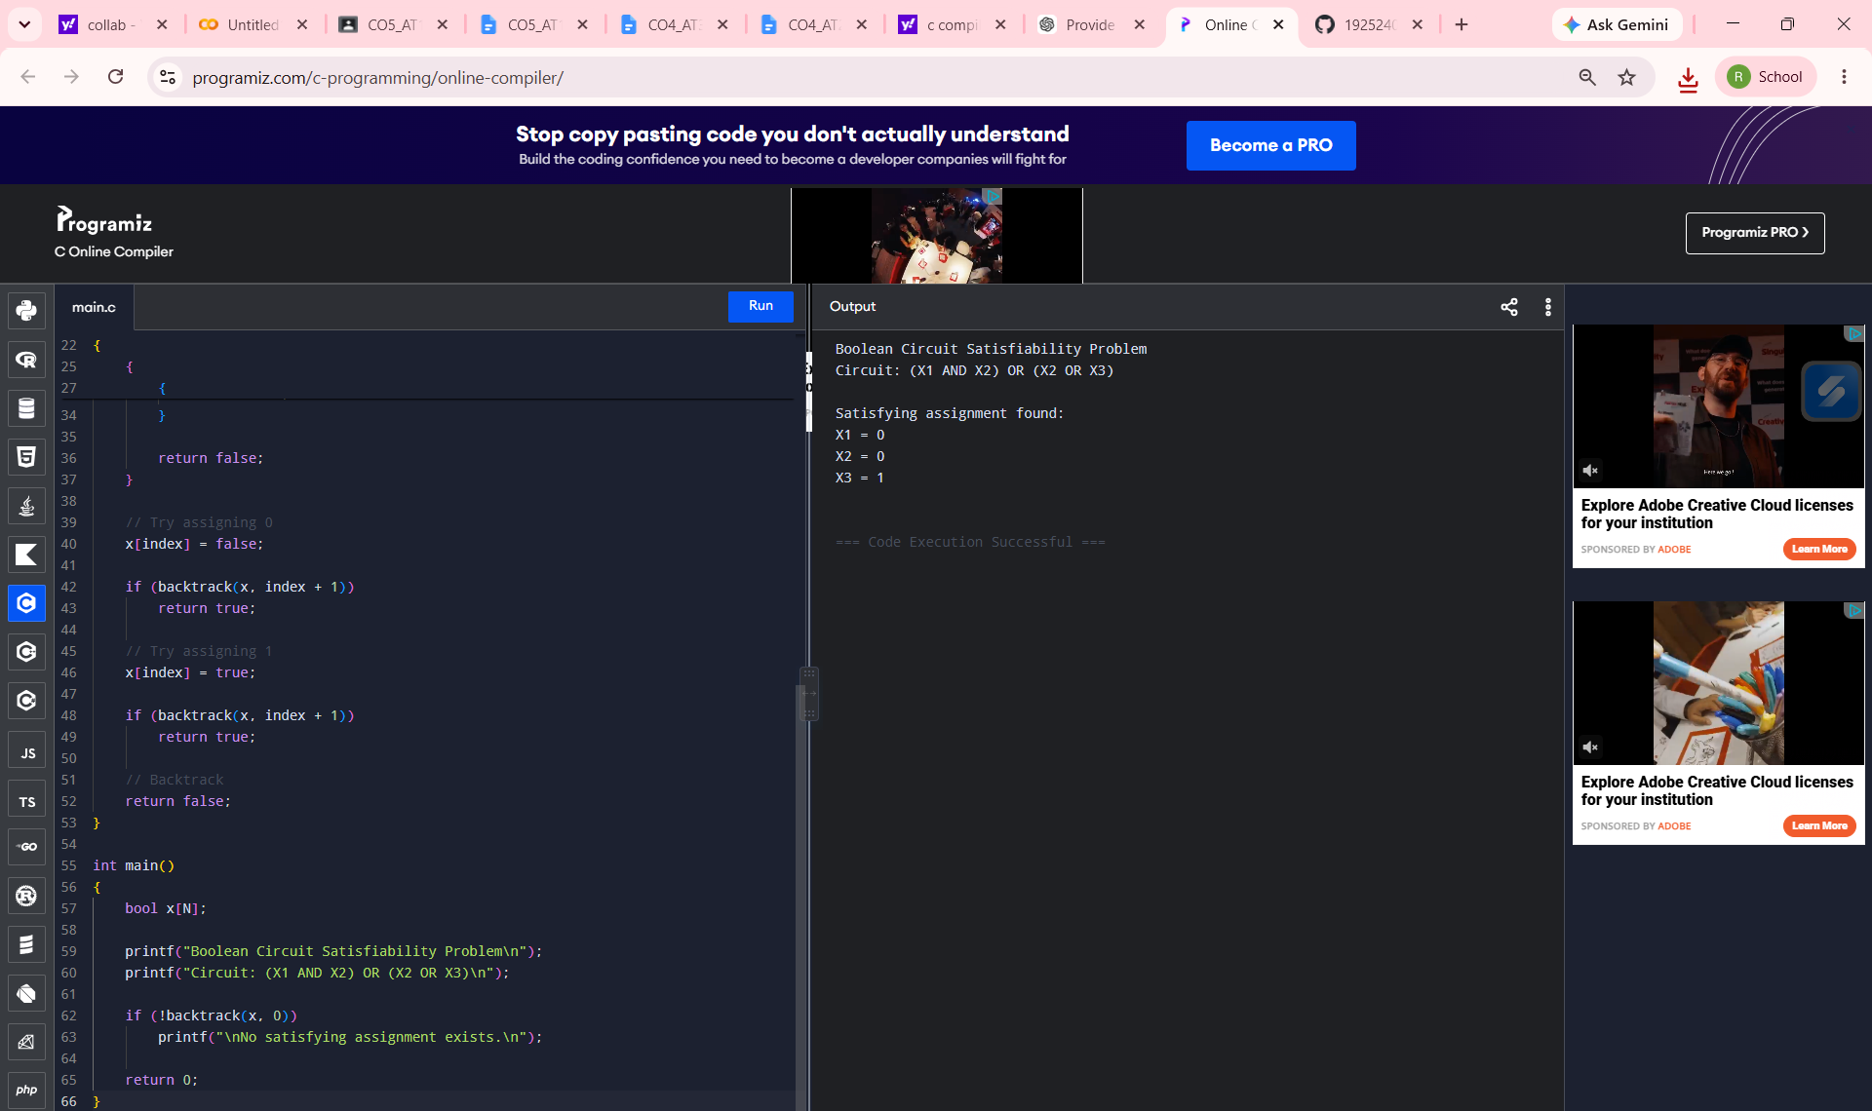
Figure 1: Program execution and output
Observed output:
Boolean Circuit Satisfiability Problem
Circuit: (X1 AND X2) OR (X2 OR X3)

Satisfying assignment found:
X1 = 0
X2 = 0
X3 = 1

WORKING OF THE PROGRAM
- The program creates an array of three Boolean variables.
- The backtrack() function starts with X1 and recursively assigns values.
- For each variable, the algorithm first tries 0 and then tries 1.
- When all three variables are assigned, evaluateCircuit() computes the gate outputs.
- For X1 = 0, X2 = 0 and X3 = 1, G1 = 0 AND 0 = 0.
- For the same assignment, G2 = 0 OR 1 = 1.
- Therefore, the final output is G1 OR G2 = 0 OR 1 = 1.
- Since the final output is TRUE, the assignment is accepted and printed.

BACKTRACKING AND PRUNING
Backtracking is used to explore the Boolean search space recursively. Each recursive level represents one input variable. The algorithm explores one assignment and, if it does not lead to a satisfying solution, returns to the previous level and tries the alternative value.
In this implementation, the main pruning occurs when a satisfying assignment is found: the recursive calls immediately return TRUE, so the remaining combinations are not explored. This avoids unnecessary computation once a valid assignment has been identified.

TIME AND SPACE COMPLEXITY
Complexity | Analysis
Time Complexity | O(2^N) in the worst case, because there are 2^N possible assignments for N Boolean inputs.
Space Complexity | O(N) auxiliary recursion/assignment space, excluding the circuit representation.

CORRECTNESS / JUSTIFICATION
The algorithm is correct because it considers both possible Boolean values for every input variable. Therefore, every possible assignment can be reached in the search tree unless the algorithm has already found a satisfying assignment. At a complete assignment, the circuit is evaluated according to the specified AND and OR gate operations. If the output is TRUE, the assignment satisfies the circuit. Thus, the reported assignment is a valid satisfying assignment.

NP-COMPLETE NATURE
Boolean Circuit Satisfiability is an NP-Complete decision problem. A proposed assignment can be verified efficiently by evaluating the circuit, which establishes membership in NP. The general satisfiability problem for Boolean circuits is computationally difficult, and circuit satisfiability is a standard NP-Complete problem. The backtracking approach used here may require exponential time in the worst case as the number of input variables increases.

RESULT
The Boolean Circuit Satisfiability problem was successfully implemented using C and a recursive backtracking approach. The program found the satisfying assignment X1 = 0, X2 = 0 and X3 = 1, for which the circuit output is TRUE. Hence, the given Boolean circuit is satisfiable.

